



Implementation Plan

CAIRN

CONGREGATION

DANIEL DECARLO

DECARLO DEVELOPER’S

200 MANOR AVE, LANGHORNE PA

19047

Purpose of Implementation Plan:

Cairn Congregation is a new software platform to connect fellow alumni and students of Cairn. We want Cairn Congregation to establish and build upon relationships with in the Cairn community. This Implementation Plan will explain the necessary steps to deploy Cairn Congregation to the public. Deployment is an essential step with software development because if there is no implementation of software than there is no software users can access.

What is implementing software?

Implementing software is releasing the software to the public. The software created by the development team has been completed and all the documentation for the software has been completed as well. Before implementing software to the public it is highly recommended that users test your application.

Testing:

Testing is an essential step for implementation. Users testing the application shouldn’t just be the development team because they were the ones who created the software so they know what is expected. The goal of testing is to see if the software breaks and if the correct functions are working. Using test scripts is a helpful way to show that your software is working correctly and records if there are any issues with certain functions.

Deployment:

When testing is completed then it is time for deployment. Deploying a piece of software can be complicated and requires different elements. For this instance of deployment we will be implementing our software on Cairn’s remote desktop server.

Step One: Log into remote desktop. Click the start button and type remote desktop. Then click enter. A prompt will display.

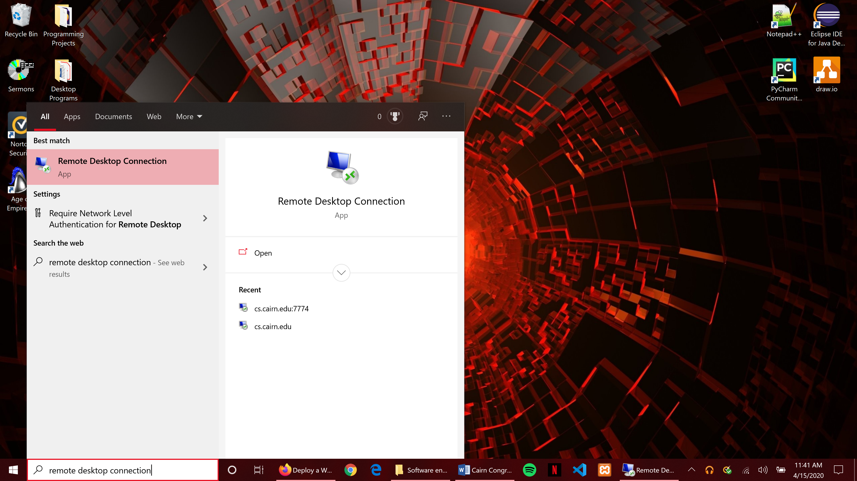

Step Two: Connect to the remote desktop connection for Cairn it is cs.cairn.edu.

***You will be asked for credentials in order to connect. Only specific users have access to this remote desktop. Please communicate with Tech Services to find your information****

Step Three: Look for the Putty application.

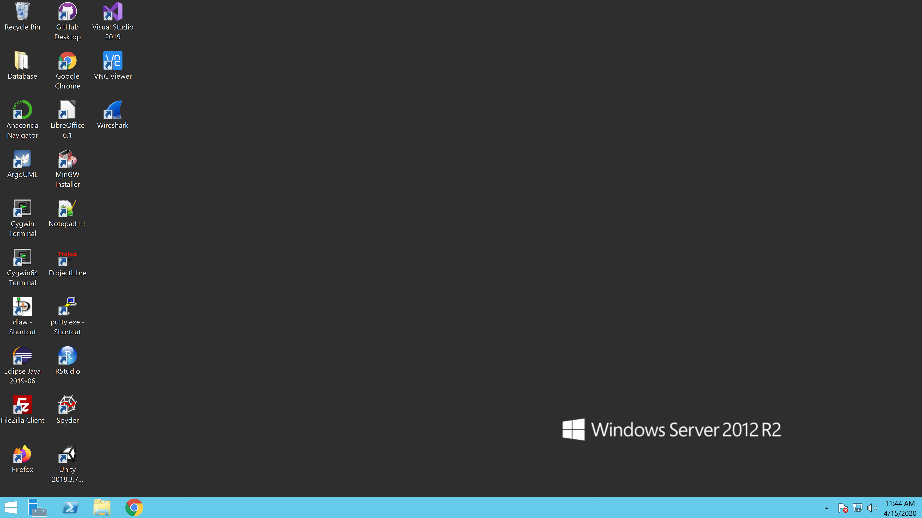

Step Four: Launch Putty. A prompt will appear asking you to enter the host name.

**This information is blocked out. If you need the information please contact tech service. **

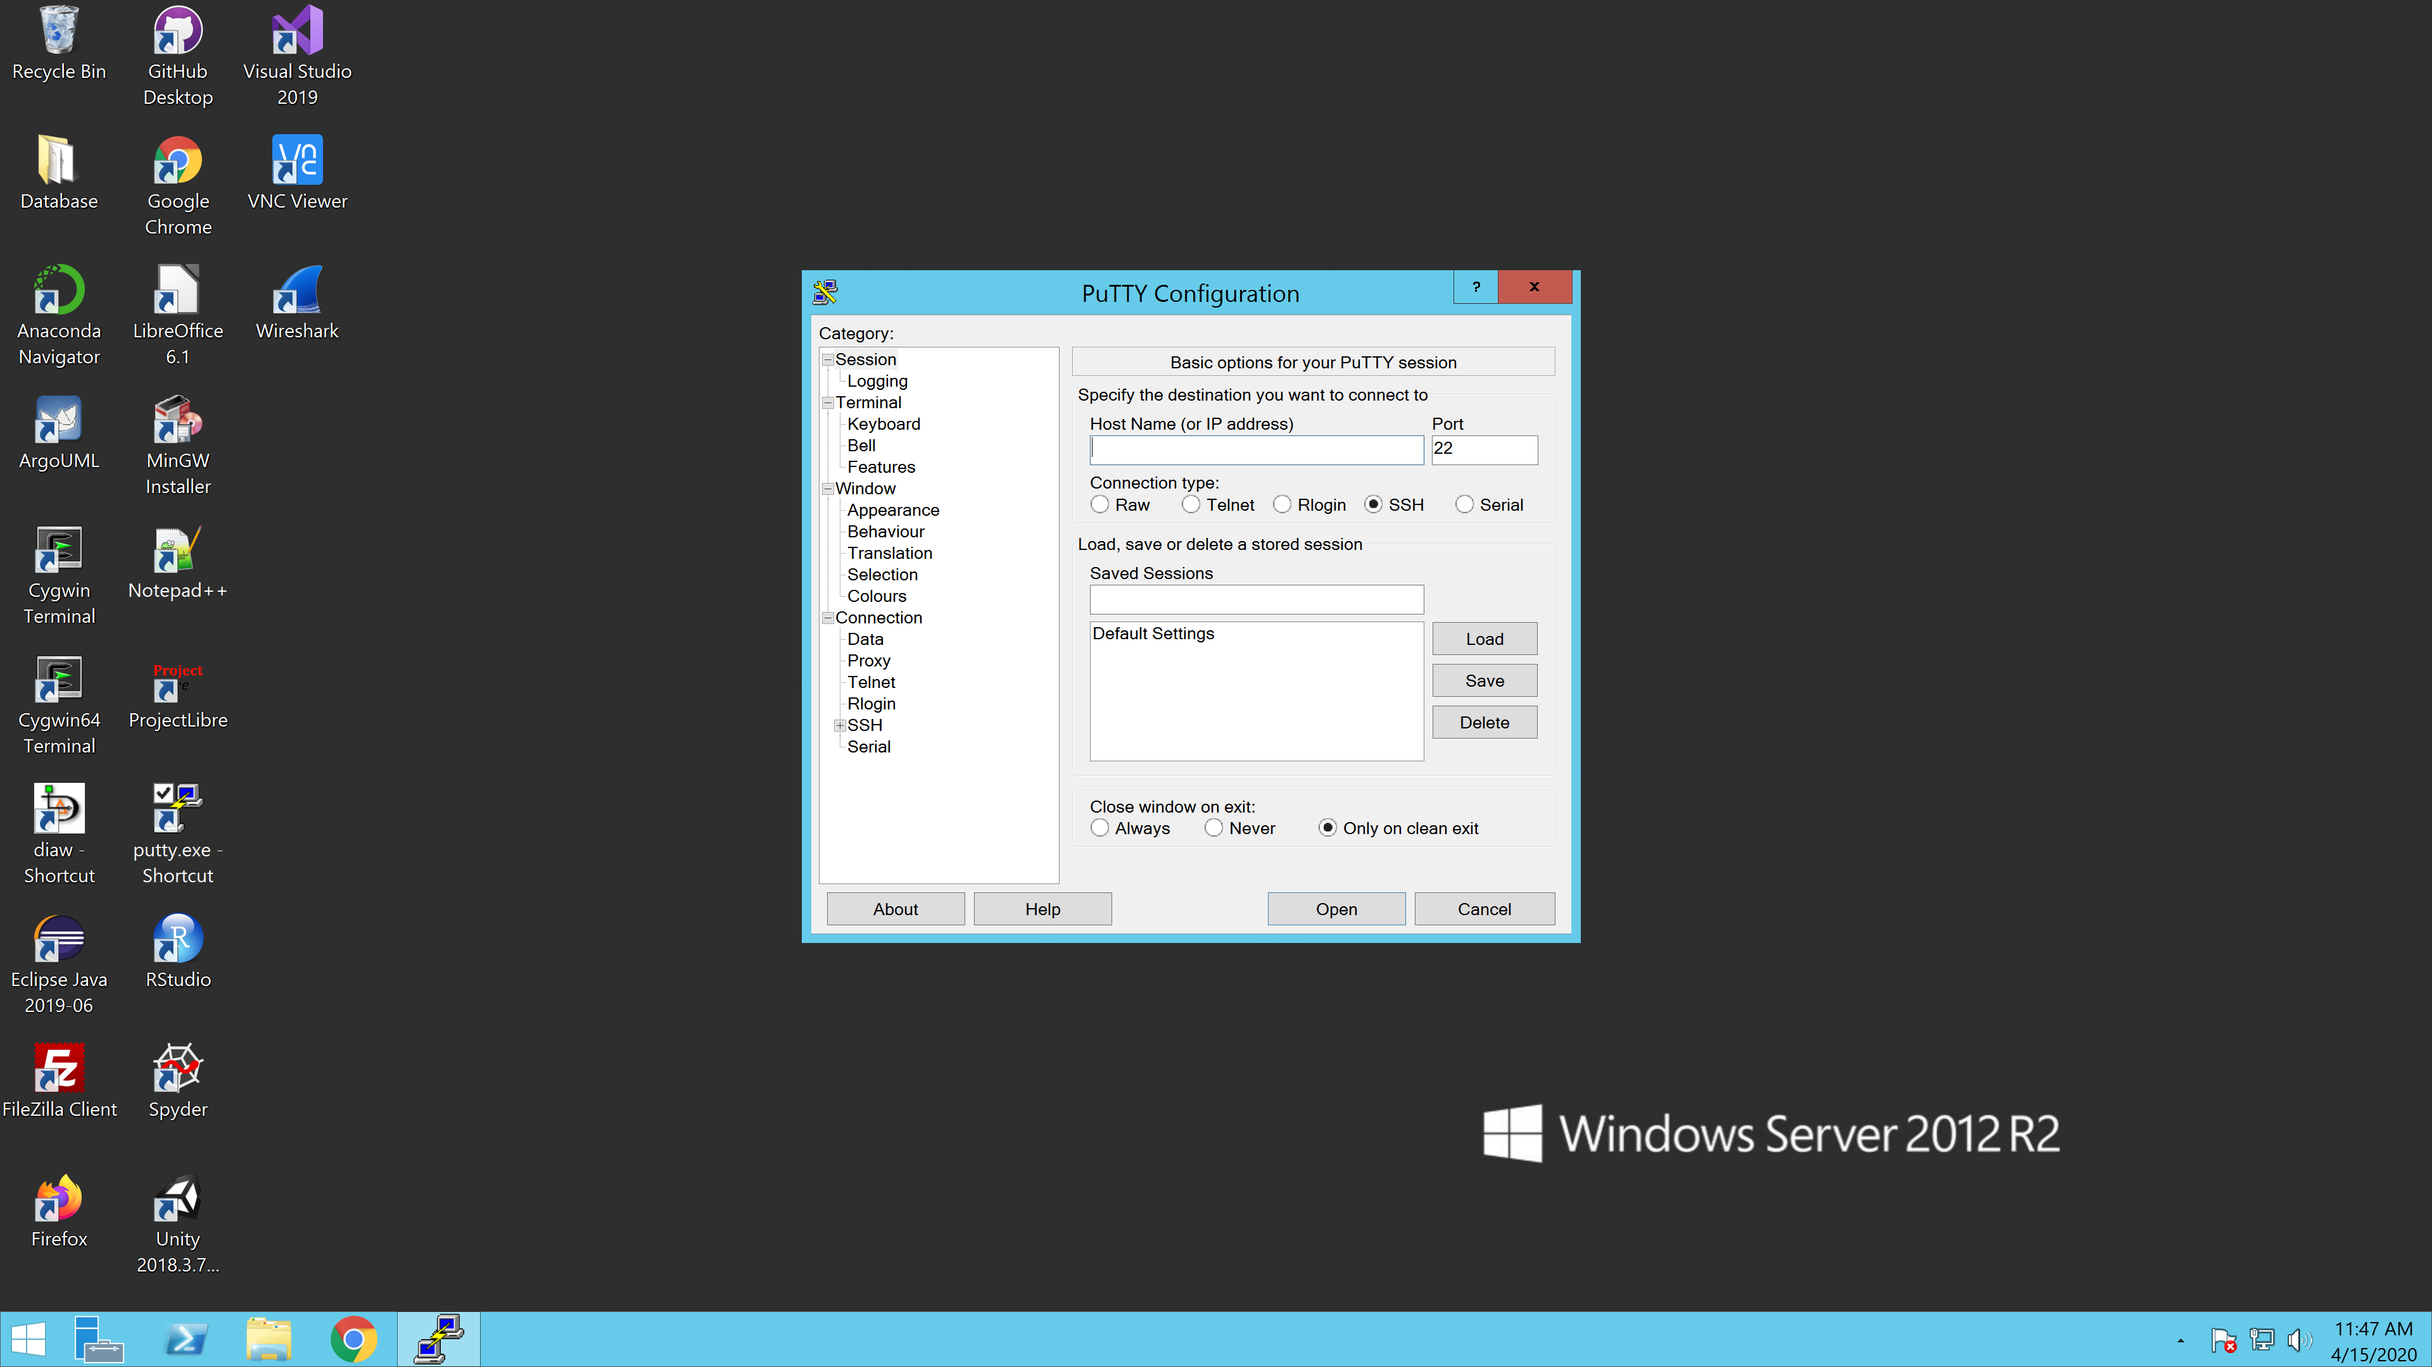

Step Five: Once connected login into the Putty Command Prompt.

**This information is blocked out. If you need the information please contact tech service. **

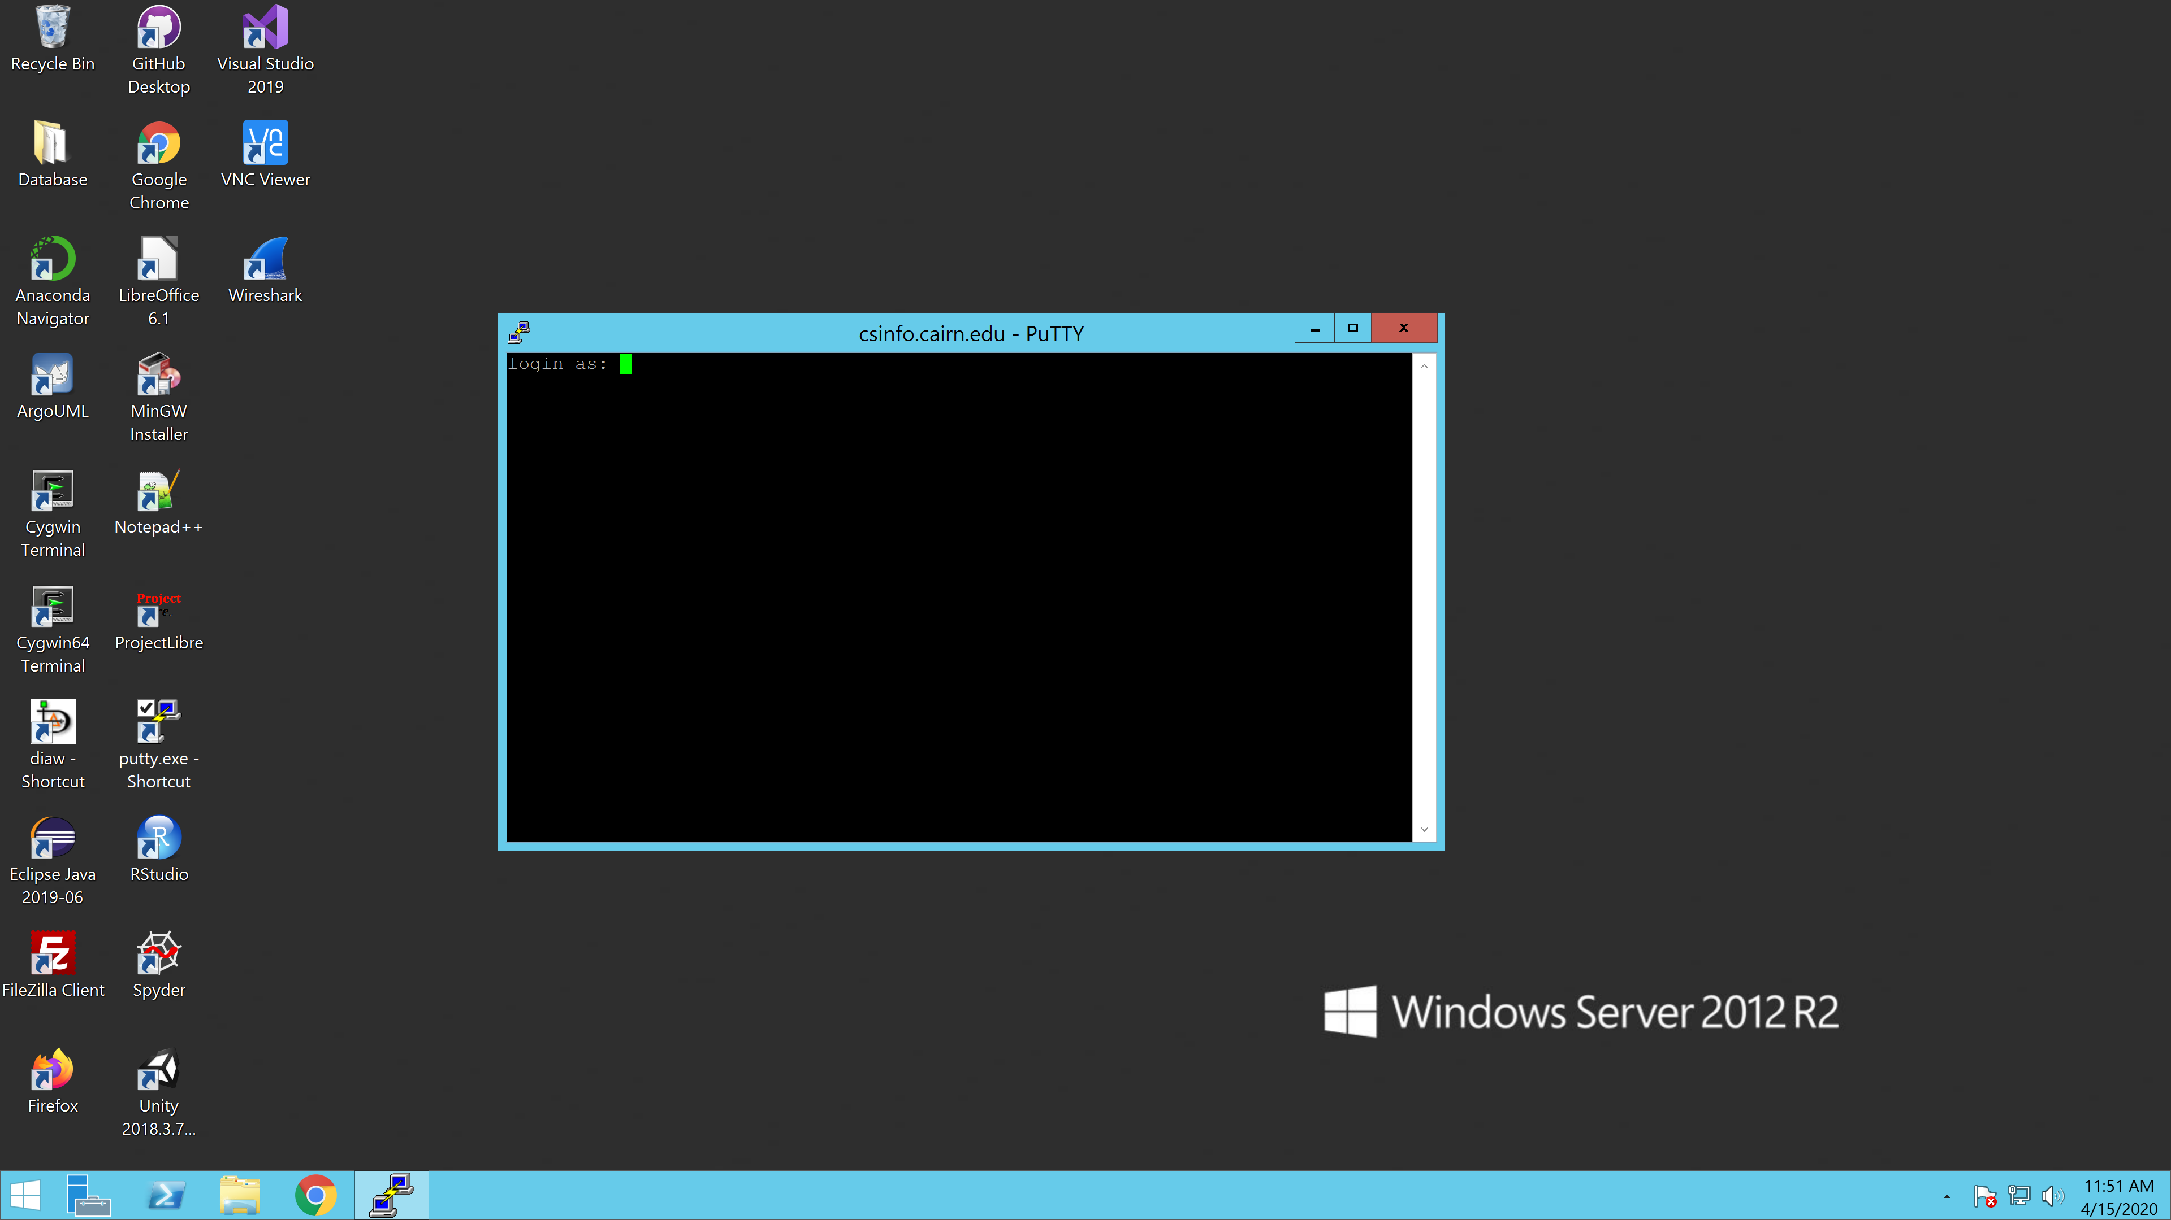

Step Six: Log into your GitHub and make sure the database connection file is corrected so that there is a connection to the database.

**This information has been censored because of its sensitive content. Please contact Tech services for database information. **

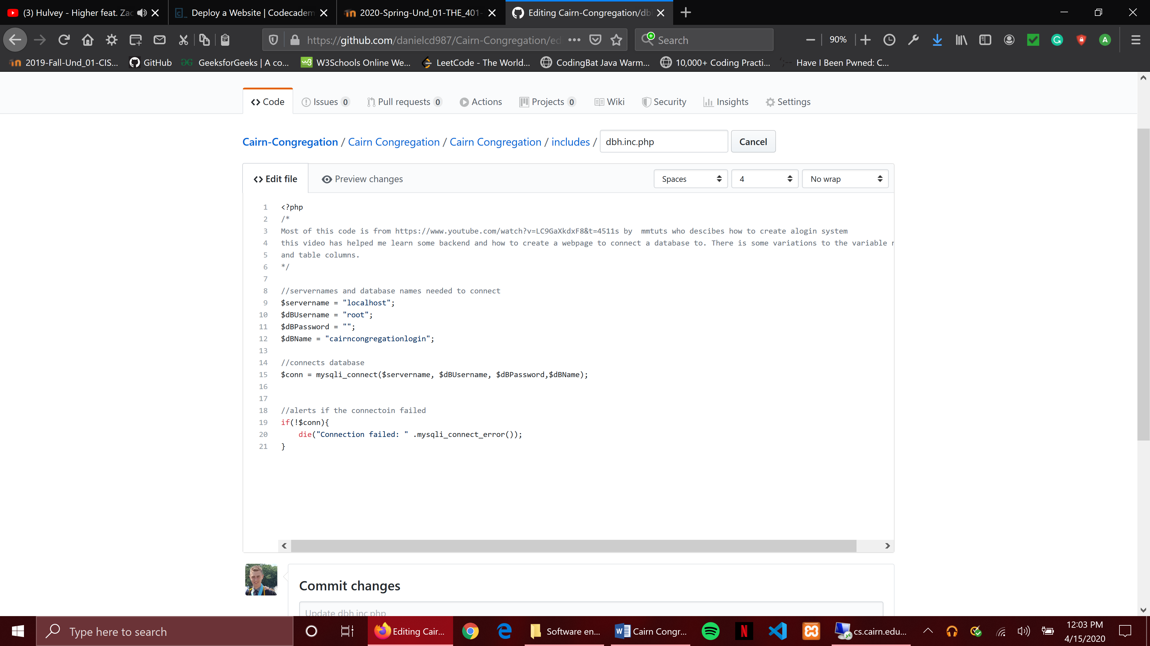

Step Seven: Upload software’s files from GitHub. Log into your GitHub and get the clone link. Copy this link. **Make sure that files are uploaded. **

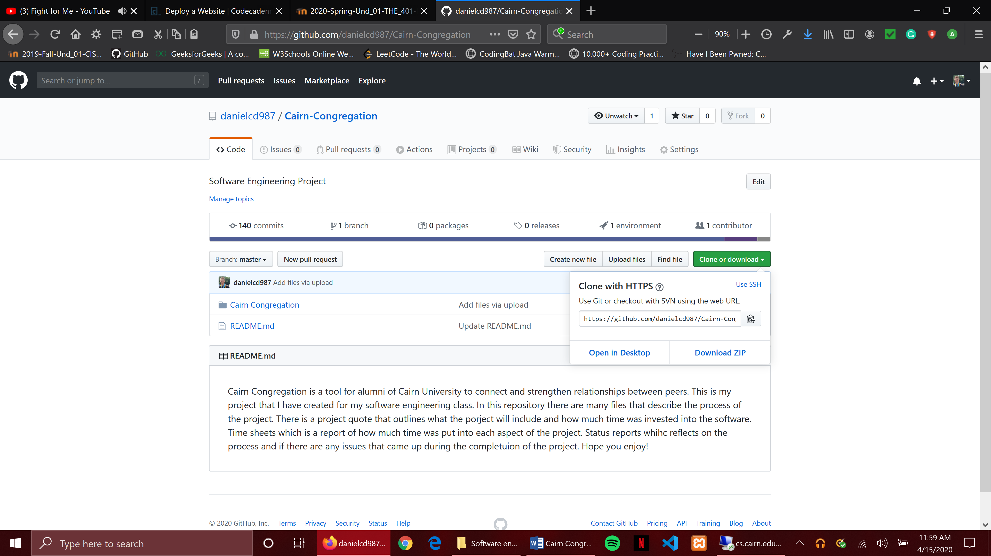

Step Eight: Go back to the putty command line in the remote desktop. Type the command ***wget*** and then right click to paste the GitHub repository link. Click enter.

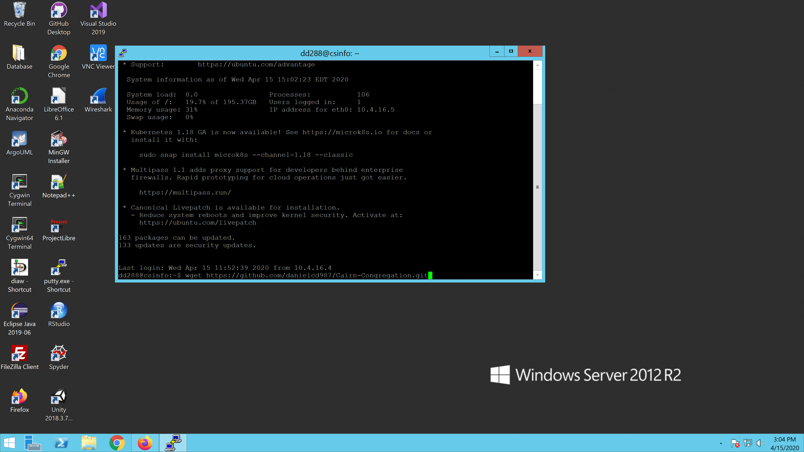

Step Nine: After putty gets the repository from the given link, enter the command git clone with the GitHub repository link. Then click enter.

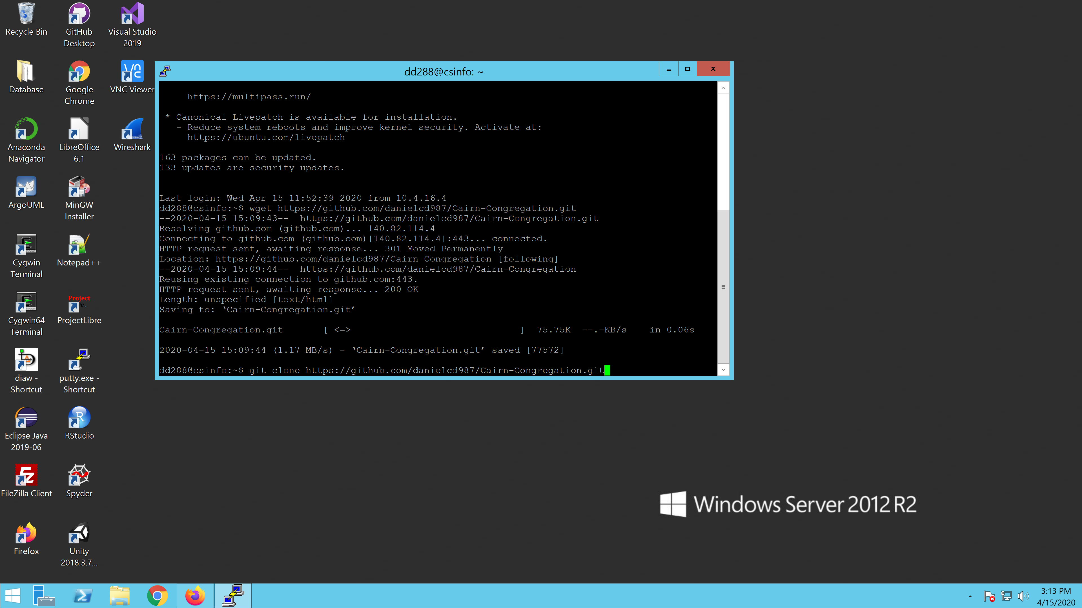

Step Ten: After the cloning process is completed then use the command ls to display the files in the directory.

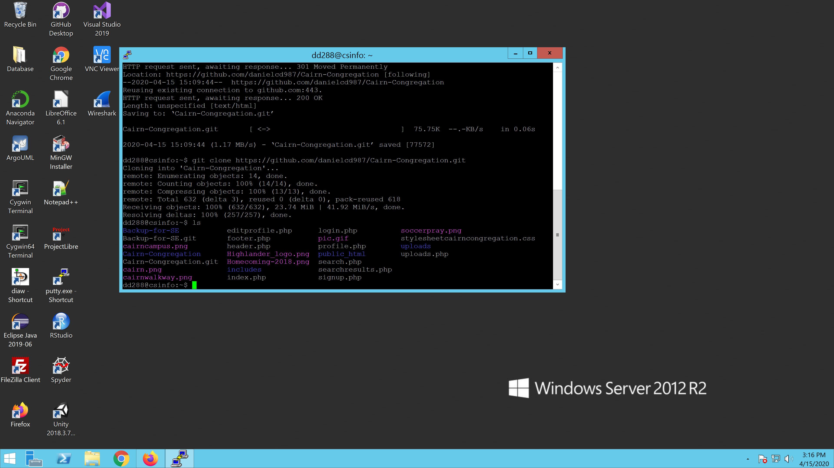

Step Eleven: After checking the list of the files type in the command prompt cd Ba (then click the tab button). Clicking the tab button finishes the statement.

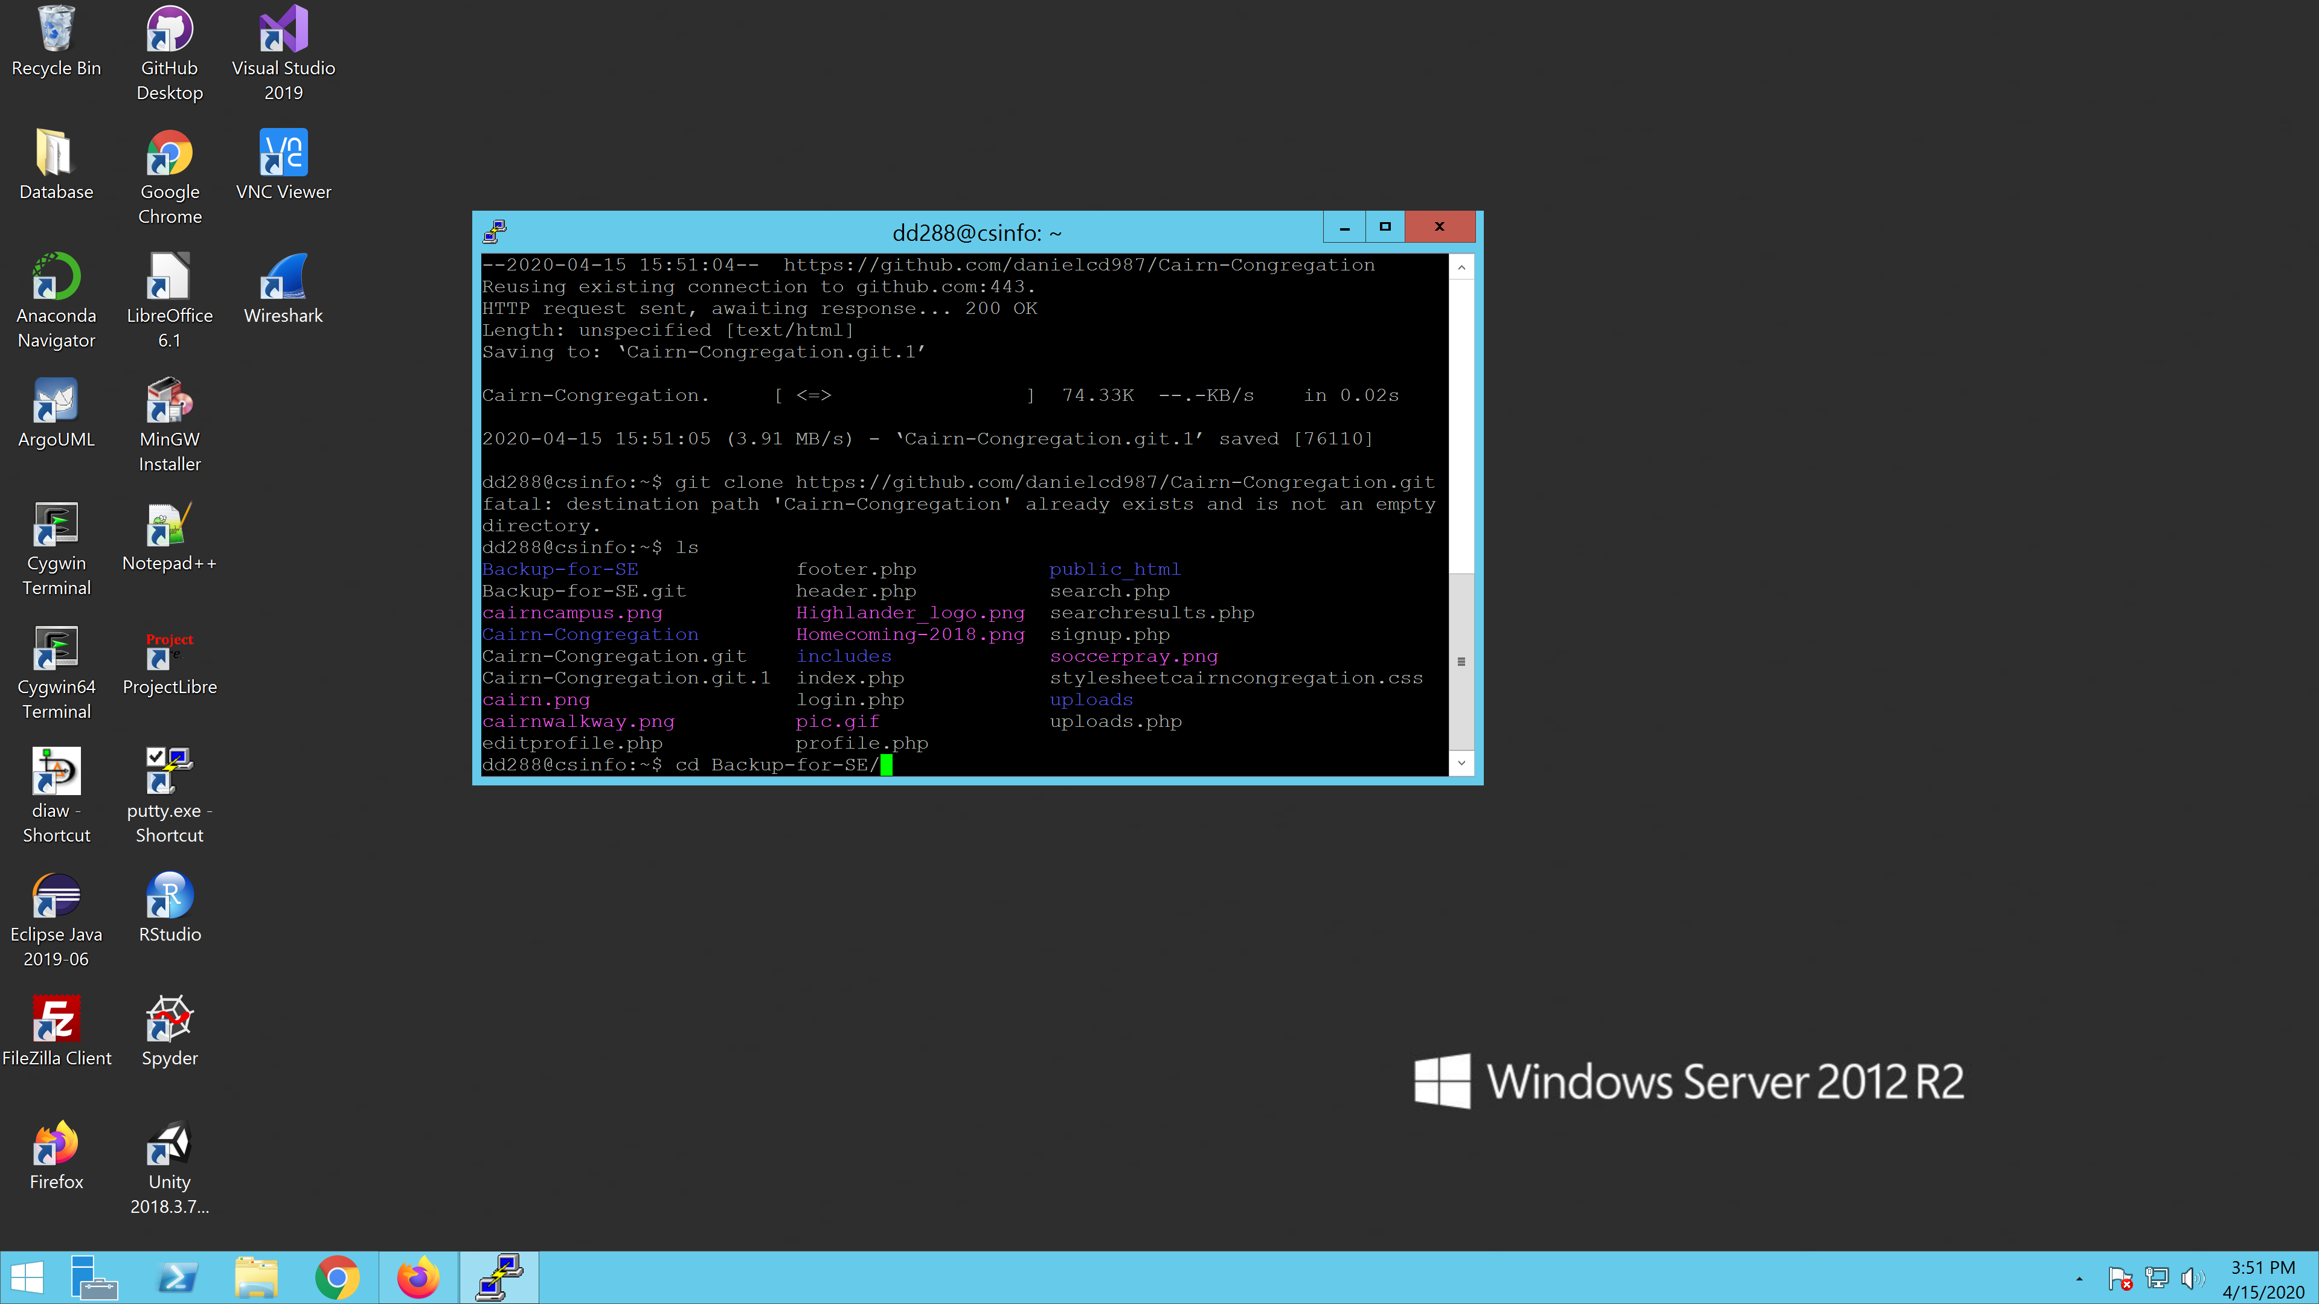

Step Twelve: After clicking enter type in the command cd Cairn \ Congregation.

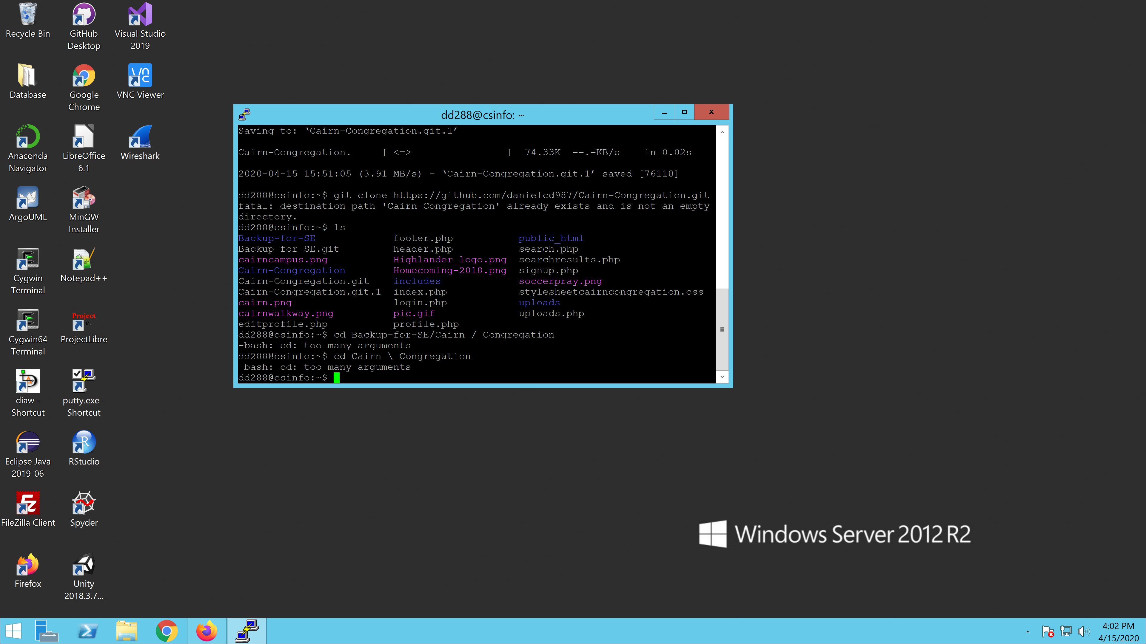

Step Thirteen: Next type in the command mv * ../.. (This moves the files into the directory.

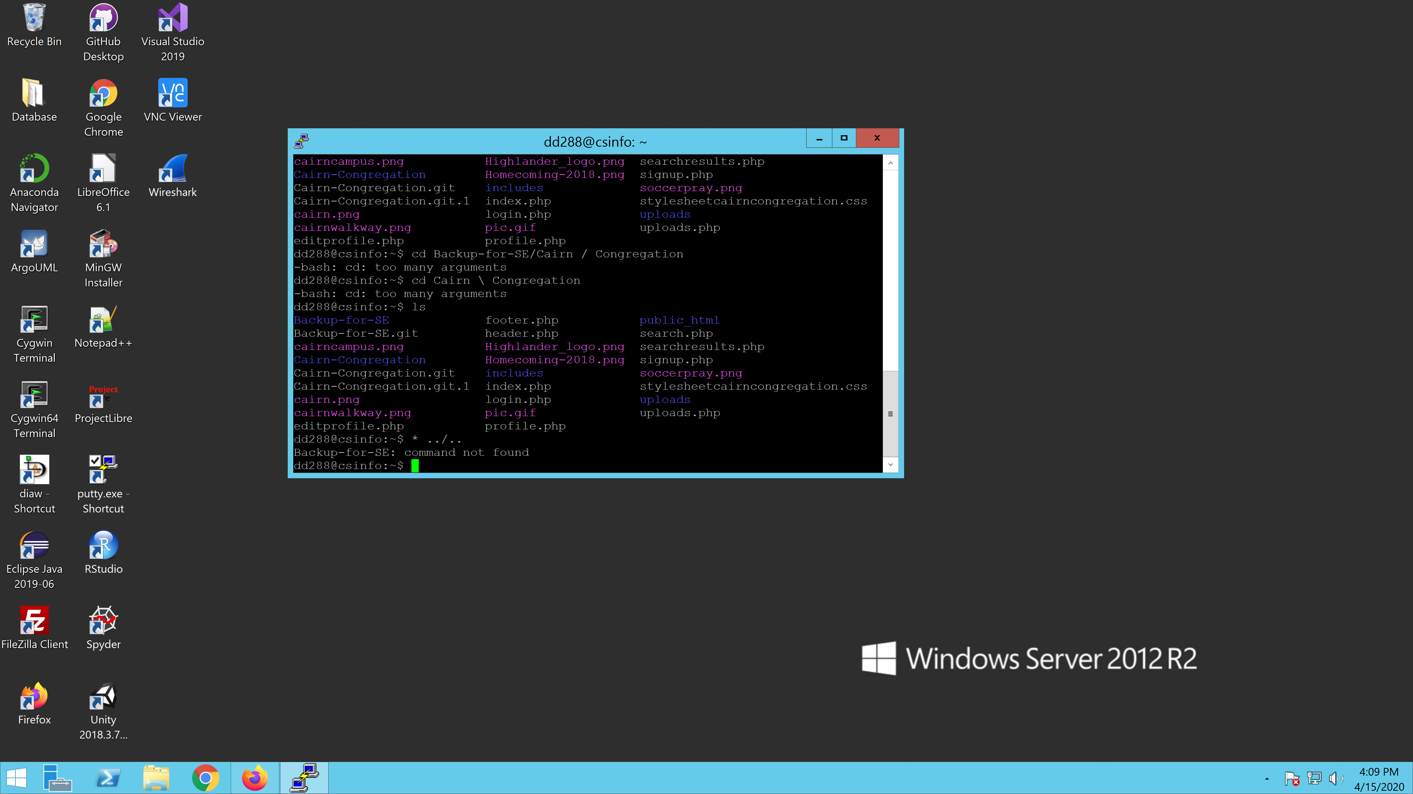

Step Fourteen: Then type in the command ls to see if the files have been moved. If there is a file already there in the directory that shouldn’t be there use the command rm (file name.type)

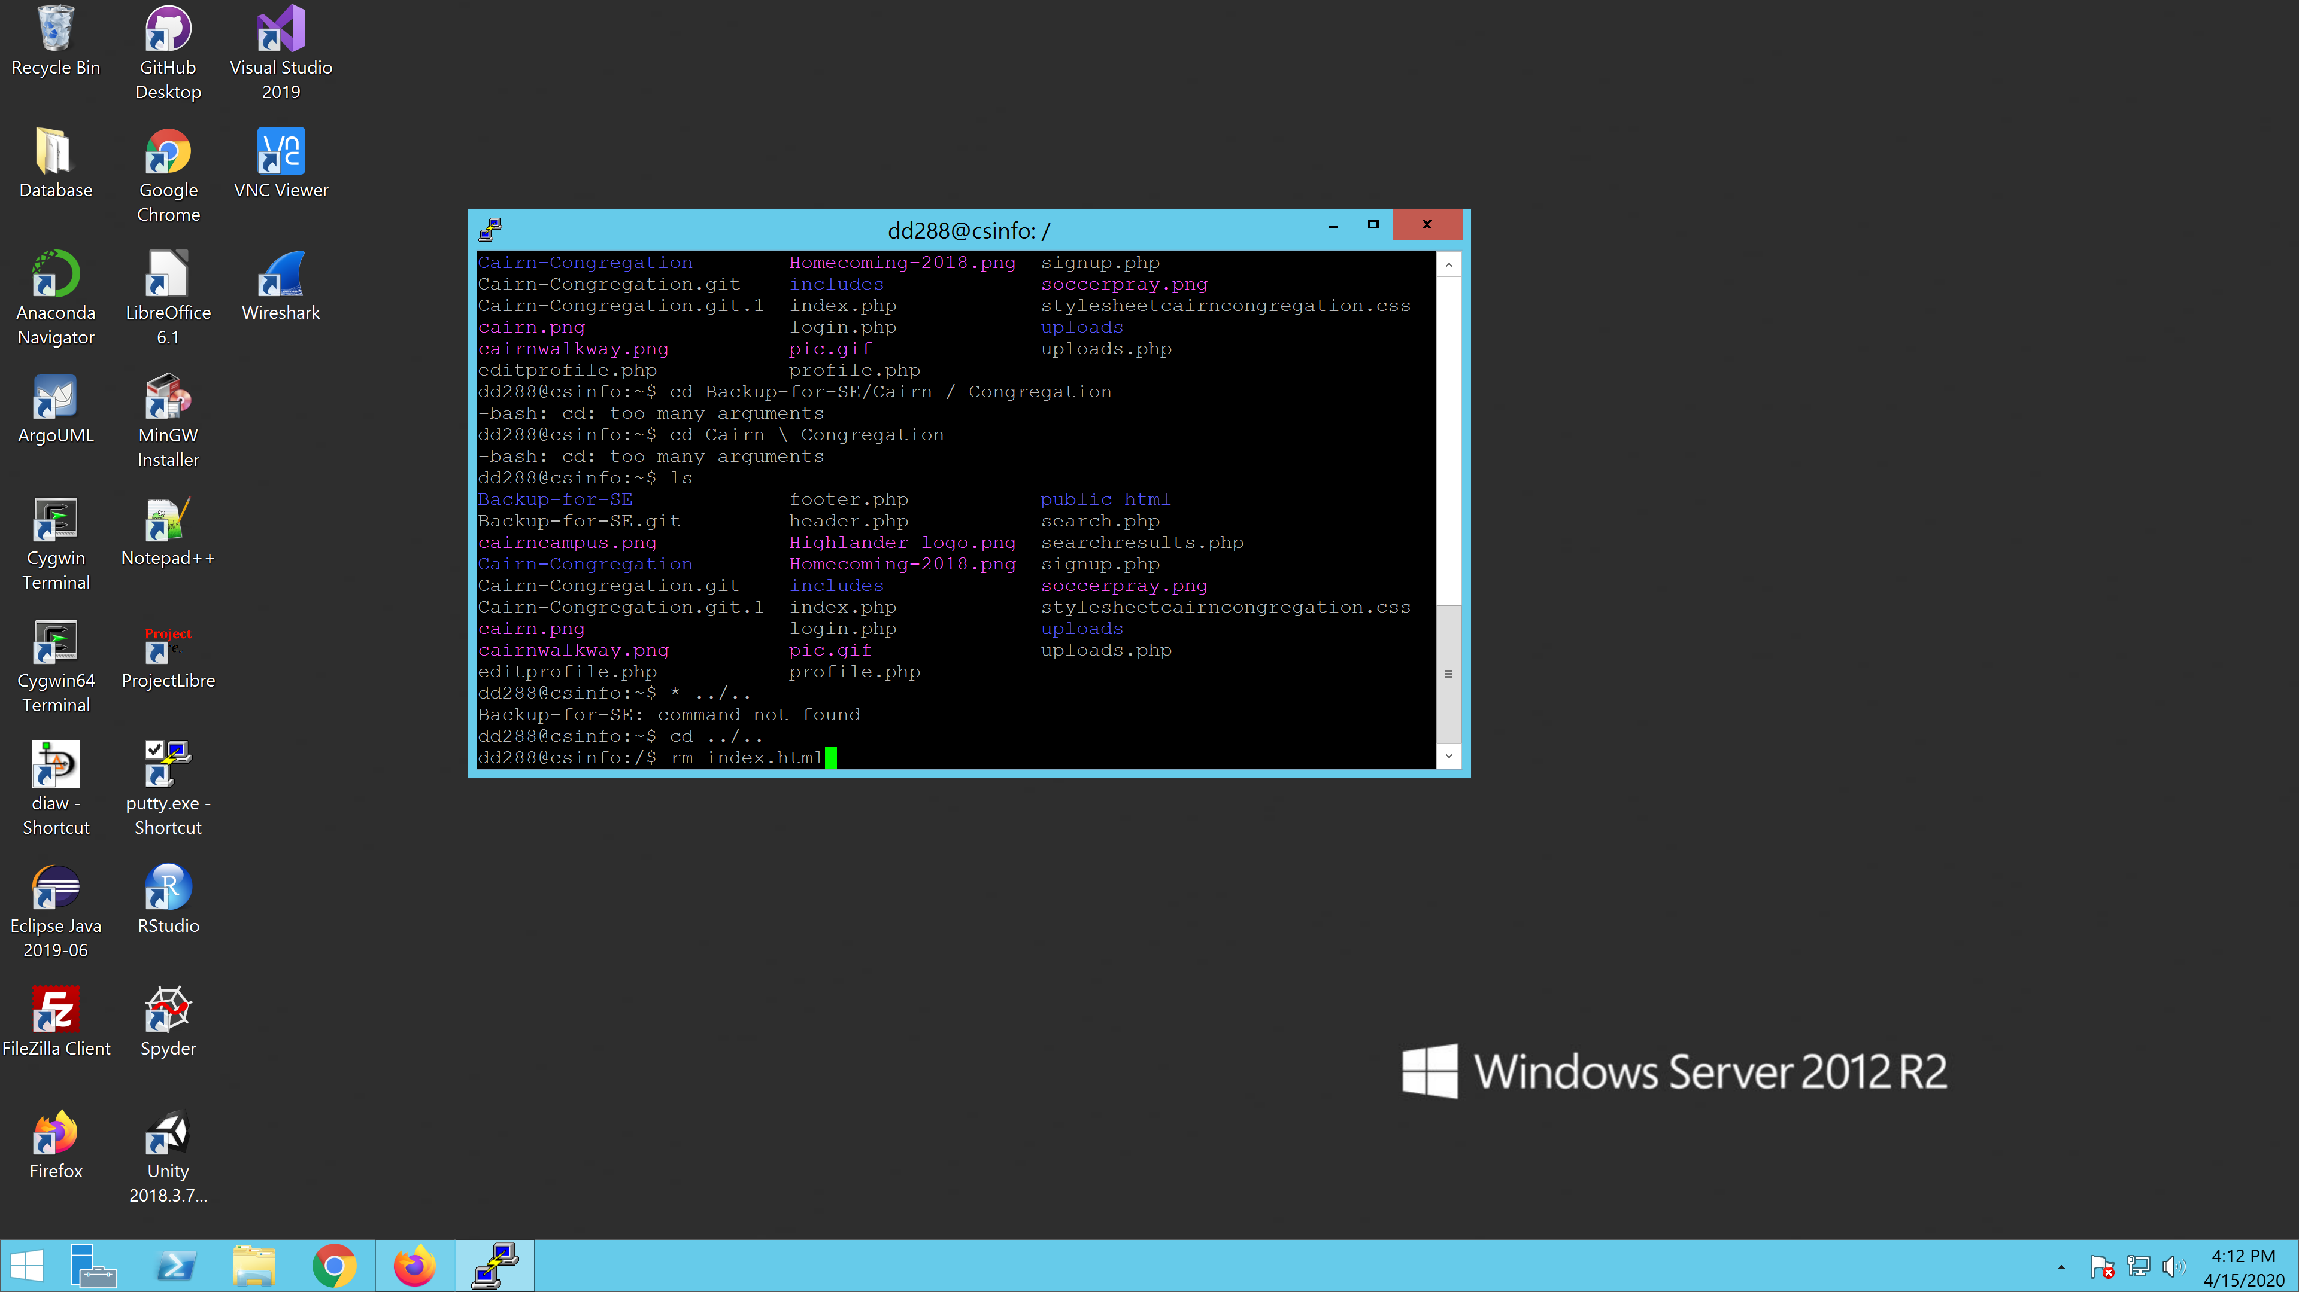

Step Fifteen: To see if the files uploaded correctly go to the URL csinfo.cairn.edu/~(username).

For this we will use the username dd288. If successful you will see the site appear.

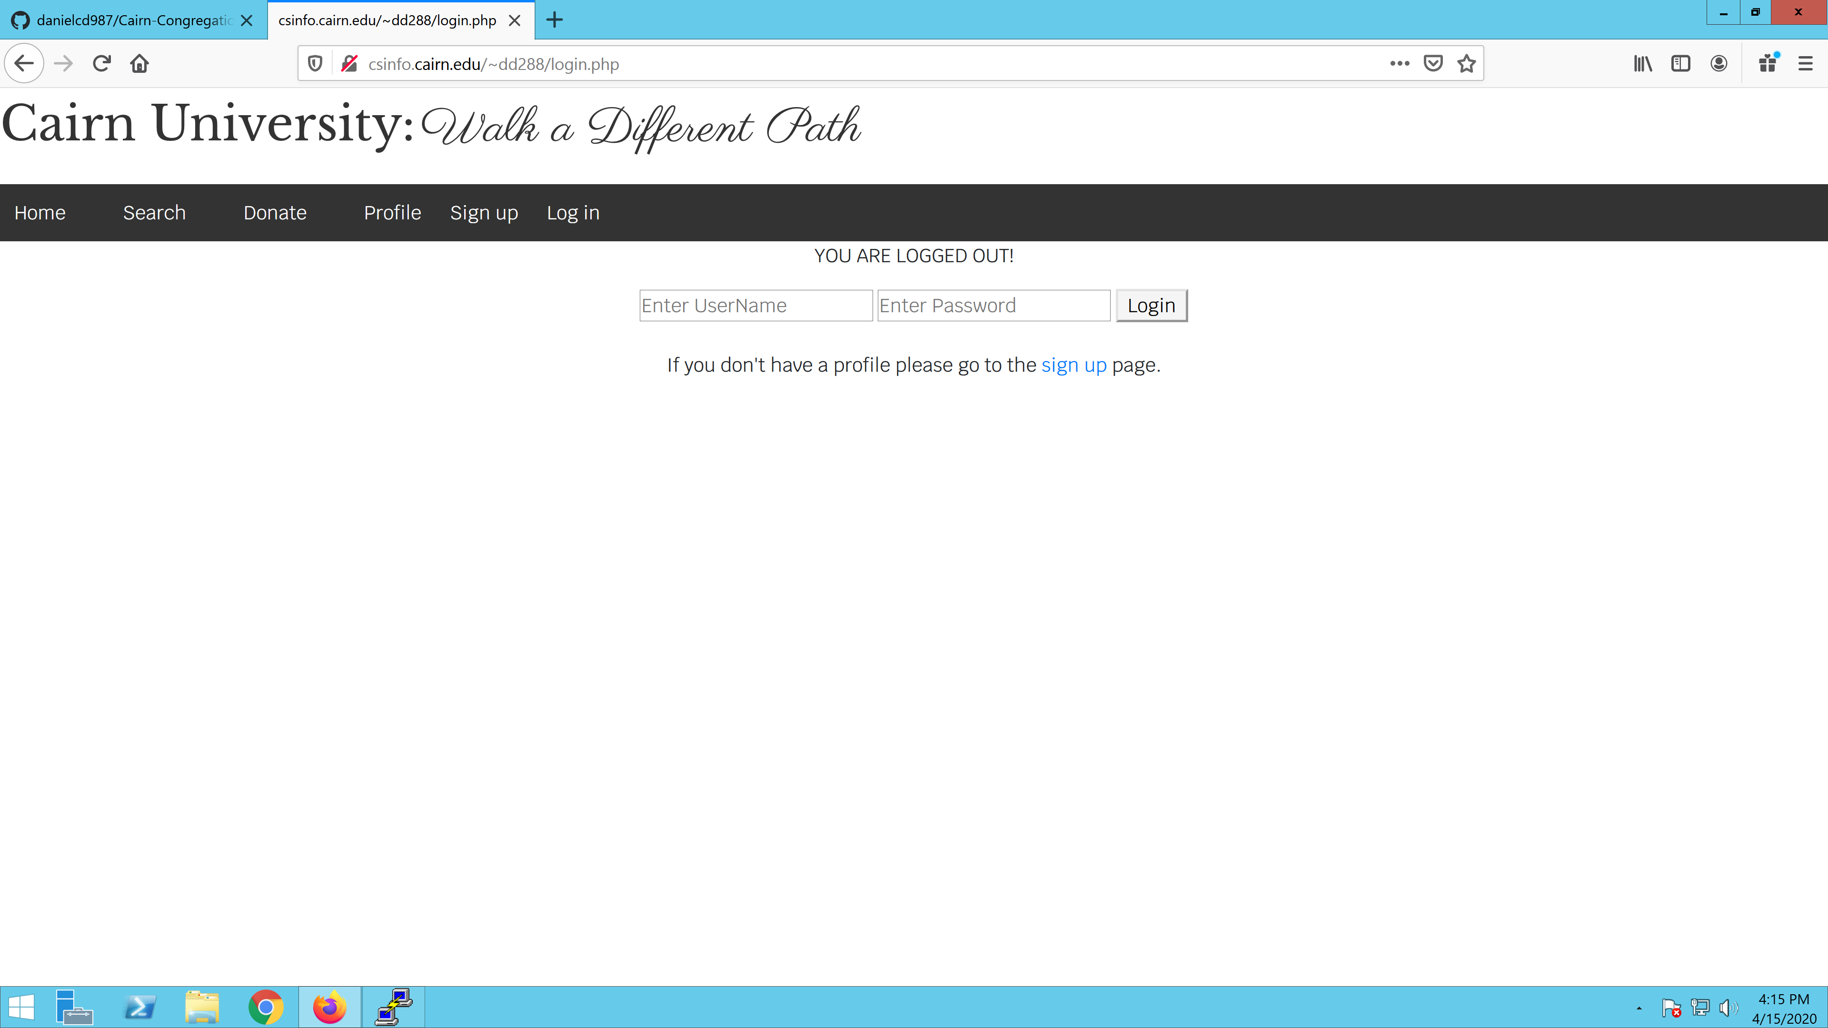

Thank you for choosing Cairn Congregation as your platform to connect with fellow alumni and students. We hope you enjoy the experience we provide and we love to hear your feedback.

If there are any questions or concerns please feel free to reach out to us.

Cairn University

(800) 366-0049

Developer:

Daniel DeCarlo

Dd288@cairn.edu